8.97: Apply conservation of energy to the explosion. Just before the explosion the sheel is at its maximum height and has zero kinetic energy. Let  be the piece with mass 1.40 kg andbe the piece with mass 0.28 kg. Let  and 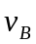 be the speeds of the two pieces immediately after the collision.

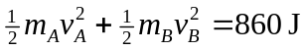

Since the two fragments reach the ground at the same time, their velocitues just after the explosion must be horizontal. The initial momentum of the shell before the explosion is zero, so after the explosion the pieces must be moving in opposite horizontal directions and have equal magnitude of momentum: 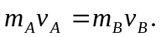

Use this to eliminate
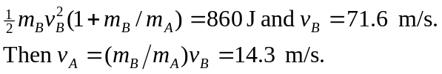

b) Use the vertical motion from the maximum height to the ground to find the time it takes the pieces to fall to the ground after the explosion. Take + downward.
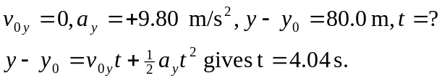
During this time the horizontal distance each piece moves is
They move in opposite directions, so they are 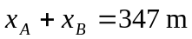apart when they land.

